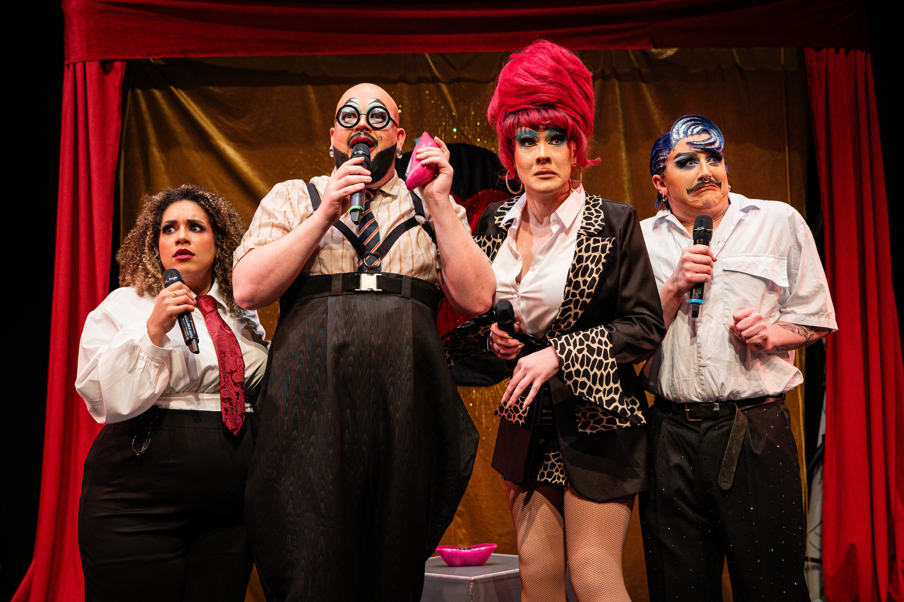
Loud & Proud
Autumn 2026
Lincoln Arts Centre
Large Print Brochure

Contextualisation & Note from Ben Anderson
This Autumn, we present Loud & Proud, a season of pop, pride and performance. From bold theatre, live music and visual art to cabaret and conversation, Loud & Proud is a season of iconic pop culture, powerful political voices, queer joy and storytelling that refuses to whisper.
We begin with Superfan: The Property of André Waszczyszyn (1-22 Oct), a first-of-its-kind exhibition celebrating the extraordinary collection of photographer and Bowie fan André Waszczyszyn. Featuring unique pop memorabilia displayed publicly for the first time, the exhibition offers a vivid portrait of fandom, identity and music history.
Lincoln Book Festival returns (1-4 Oct), celebrating the National Year of Reading with a programme of authors, ideas and conversation inspired by this year’s theme, Go All In, alongside Demo (1 Oct), our popular platform for new work-in-progress performance.
Returning by popular demand, Sh!t-Faced Shakespeare: Romeo and Juliet (8 Oct) brings the company’s gloriously chaotic take on Shakespeare back to Lincoln. Our Creative Meet Up (16 Oct) returns with free pizza, conversation and the chance for local artists and creatives to connect. Alongside this, Some Other Mirror (16 Oct) showcases a fresh performance from a local artist exploring queer identities.
Music and performance continue with DIVAS! (24 Oct), where OUTloud Lincoln’s LGBTQIA+ community choir celebrates iconic songs from iconic artists in an evening of pop anthems and collective joy. Later in the season, acclaimed cabaret revue Send In The Clowns: Unpopular! (14 Nov), will be a riotous celebration of mega musicals, drag and musical theatre spectacle featuring Fatt Butcher (from The Voice UK and winner of Drag Idol UK) and a stellar line-up of Midlands cabaret artists.
In November, Annabel McCourt premieres her landmark new commission Ad Astra (12 Nov – 3 Dec) in the gallery, developed through her associateship with Lincoln Arts Centre. Expanding on her earlier work Per Ardua, the project reflects on the experiences of LGBTQ+ RAF personnel affected by the historic ban on homosexuality in the armed forces.
Referencing the RAF motto Per Ardua Ad Astra (“through adversity to the stars”), McCourt’s earlier work deliberately crossed out Ad Astra, reflecting how the historic “gay ban” denied LGBTQ+ personnel the chance to fully realise their potential.
Not forgetting the students who call our building home, you’ll be treated to three days of BA Music Showcases (30 Nov – 2 Dec), with genre-spanning music shaped by resistance.
Finally, our much-loved Christmas show returns with a boop beep as Toad of Toad Hall takes to the stage in The Wind in the Willows (10-20 Dec), bringing festive chaos, adventure and family fun to close the season.
Ben Anderson
Creative and Executive Director, Lincoln Arts Centre

www.lincolnartscentre.co.uk
01522837600
Join the conversation
@lincsartscentre #LoudandProud

Café Bar
Our Café Bar is open 8.30am - 6.00pm* every weekday and one hour prior to events.
*Opening times may vary due to changes in seasonal demand and academic timetable.
Please note that the University of Lincoln is a cash free organisation. Payments can be made by debit or credit card only at our Café Bar.

We’re Open to Ideas
The best way to start a conversation about working together is by making us aware of your work through our Open to Ideas open submission.
Our priority is nurturing the next generation of artists or artistic ideas. Often that means we are interested in artistic work that tests the boundaries of form, is challenging or is helping us to develop new audiences. Please read our Open to Ideas policy before submitting.

Every Child
Every child is creative, but not every child can access Lincoln Arts Centre, and we want to change that.
Every Child is Lincoln Arts Centre’s donation scheme to make certain every child can get creative with a visit to our purpose-built facility. Whether that be watching a show, learning a new skill or expressing themselves through their own performance or visual art.
It’s easy to donate. Just head to our website or add an optional donation when you buy a ticket.
Help us make sure that every child is welcomed into the Lincoln Arts Centre

Live Pass
If you’re aged 16-30 or a student of any age, don’t forget to sign up to Live Pass – offering a range of discounts on shows and in our cafe, plus exclusive events and a network of like-minded creatives.
Keep an eye out for Live Pass tickets prices on events and notes to say we’ll be holding a Creative Meet Up before.
Don’t miss out, sign up online or at our box office.

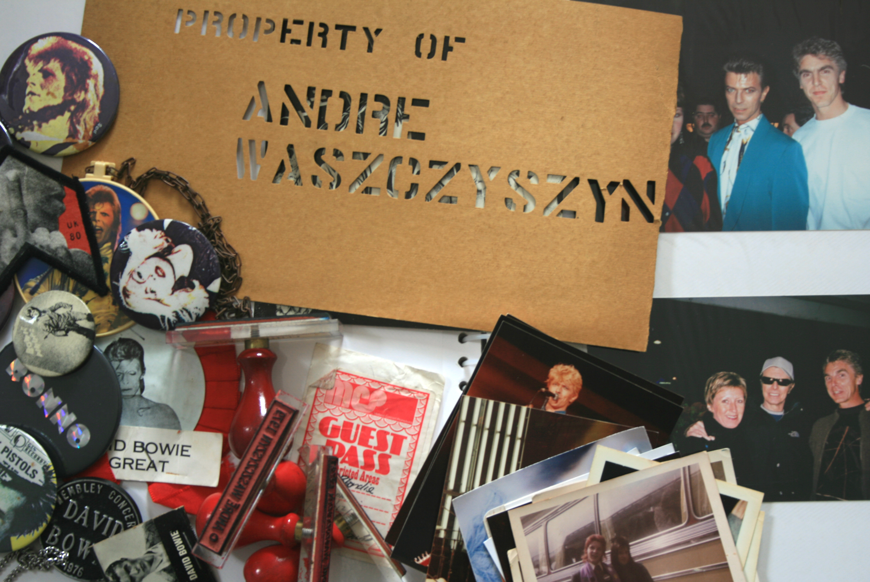
Superfan: The Property of André Waszczyszyn | 1-22 October
Gallery / Exhibition
Superfan: The Property of André Waszczyszyn opens up a hidden archive for the first time to reveal rare and unseen photographs of pop icons including David Bowie, Debbie Harry and Iggy Pop.
A self-proclaimed “superfan”, Lincolnshire photographer André Waszczyszyn followed Bowie’s tours around the world documenting every moment.

On the 10th anniversary of Bowie’s death, and what would have been André’s 70th birthday, the Lincoln School of Creative Arts have worked with André’s family and Lincoln Arts Centre to exhibit some of his unseen collection of pop and rock music memorabilia alongside his beautiful photographs taken at gigs and concerts around the world.

Superfan: The Property of André Waszczyszyn is a joyful celebration of fandom, music, abundance, and the work of a talented photographer, covering a period of history that transformed our culture.

Exhibition Opening Event 1 October 5-7pm. All Welcome.
Free entry

Follow on Instagram @uolcreativearts

Badge Making Workshop | 10 October / 11:00 - 13:00 (drop in)
Create your own badge inspired by your favourite band, singer or logo in this hands-on Superman workshop for all ages (3–100), led by illustrator Rick Rickwood on 10 October 2026. Design it, make it, and take it home.

In response to Superfan
Archival Encounters: Creative Acts of Fandom | 8-10 December 2026
Gallery / Exhibition
Developed through the BA Fine Art module Creative Archival Practice, this exhibition will present new work that responds to the Superfan Exhibition and the André Waszczyszyn archive it brings together.

Students from across the Lincoln School of Creative Arts will engage with the archive as something to think with, play with, and work through. The archive will be activated rather than only preserved, and re-shaped through imaginative, critical, and experimental practice.

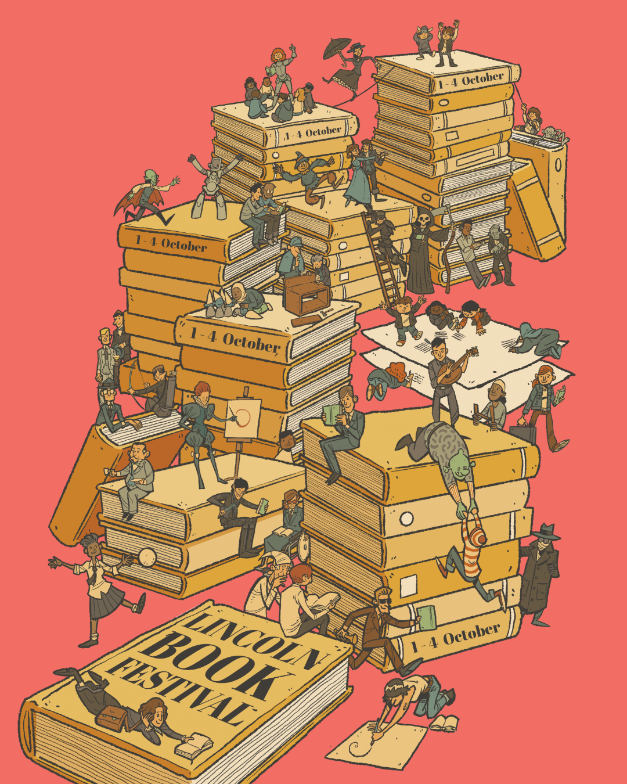 Illustration by Nick Moffat
Lincoln Book Festival | 1-4 October
Lincoln Arts Centre / Festival
Lincoln Book Festival returns from 1-4 October with events at Lincoln Arts Centre and across the city. Featuring a programme that celebrates the National Year of Reading, join us to Go All In as we explore your favourite hobbies and reading for pleasure. From Booktok panels to poetry, award winning authors to Wuthering Heights, Illustration to Flash Fiction and much more to inspire you this autumn. Sign up to our mailing list to keep up to date.

Flash Fiction Competition
We’re delighted that Lincoln Book Festival’s popular flash fiction competition is back for 2026! And we’re going all-in with this year’s theme - “Hobbies”.
The festival’s annual creative writing contest invites budding authors to produce their own super short stories of exactly 50 words – no more, no less – on a given theme or genre. This year’s theme is inspired by the National Year of Reading 2026 “Go All In” campaign, designed to help more people across the UK rediscover the joy of reading
The closing date for submissions is midnight on Monday 24th August 2026. Winners and runnersup will also have their stories published on the festival website with the opportunity to read them aloud to audiences during this year’s festival in October.

Join the Lincoln Arts Centre Book Club
An opportunity to meet fellow book lovers. Expect a variety of genres from month to month, writing prompts each month for those wanting to flex their creative muscles, and major cosy vibes.
The book club welcomes everyone 18+ and is committed to choosing books in a wide range of accessible formats.
Find out how to become a member today on our website.

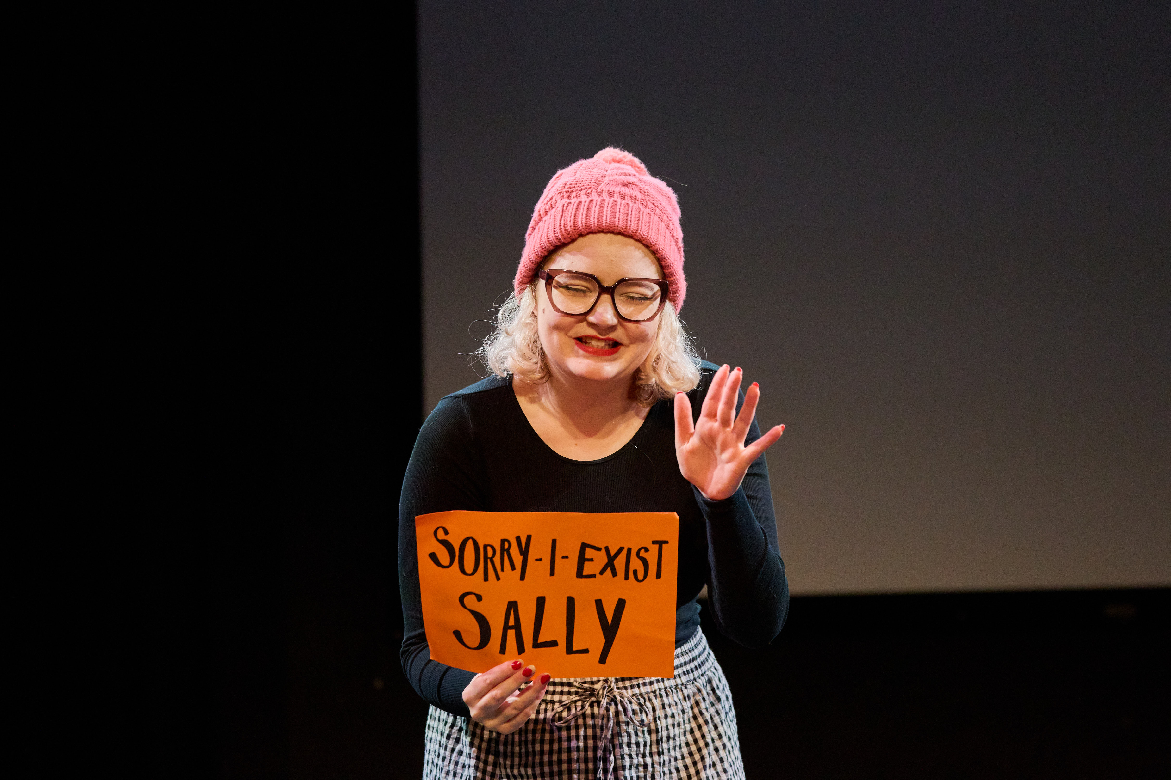Phil Crow
Lincoln Arts Centre presents
Demo | 1 October / 7pm
Studio / Mixed Arts
Be part of developing the next big thing!
Demo is your chance to see the best new artistic ideas tested out in front of an audience, often for the very first time.
Offering a selection of new work from the most exciting artists both regionally and nationally, this event encourages critical discourse in a relaxed and supportive environment.
Standard / £7 | Live Pass / £5

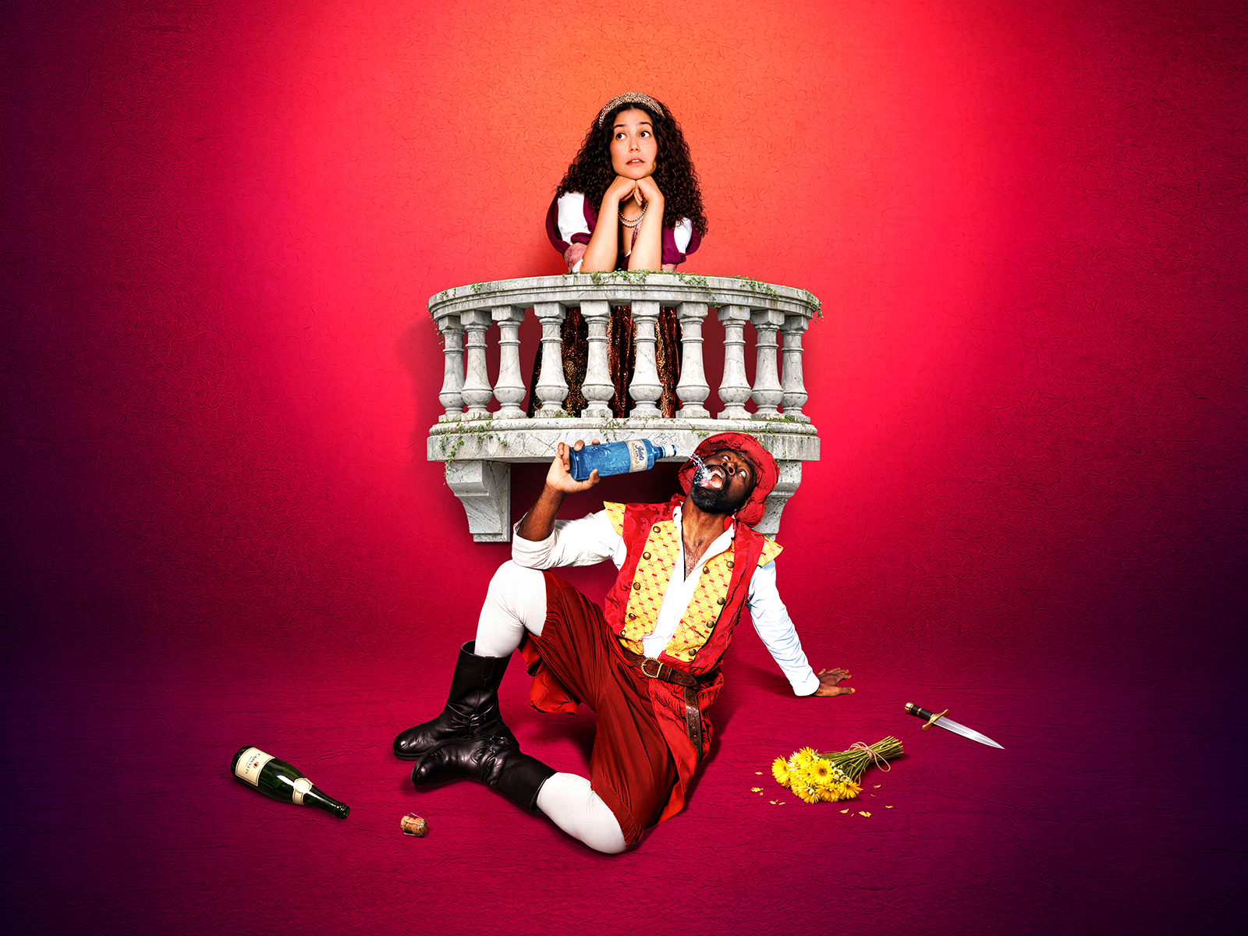
Sh!t-faced Shakespeare® : Romeo and Juliet | 8 October 7.30pm
Auditorium / Theatre
The smash-hit, internationally acclaimed, award-winning, multi-sell-out phenomenon is back.
Our cast will present an unconventional, no-holds-barred interpretation of 'Romeo and Juliet', with a tipsily tragic take on William Shakespeare's most iconic roll call of characters: from a rat-arsed Romeo to a juiced-up Juliet, a trollied Tybalt or a mashed-up Mercutio, along with enough booze to sterilise a brewery floor. This will be a tragedy like no other—the cup overfloweth.
Warning: Sh!t-faced Shakespeare® may feature foul language, nudity, disembowelled limbs and, occasionally, some Shakespeare.
Standard / £26 | Live Pass / £23
Age guidance: 16+

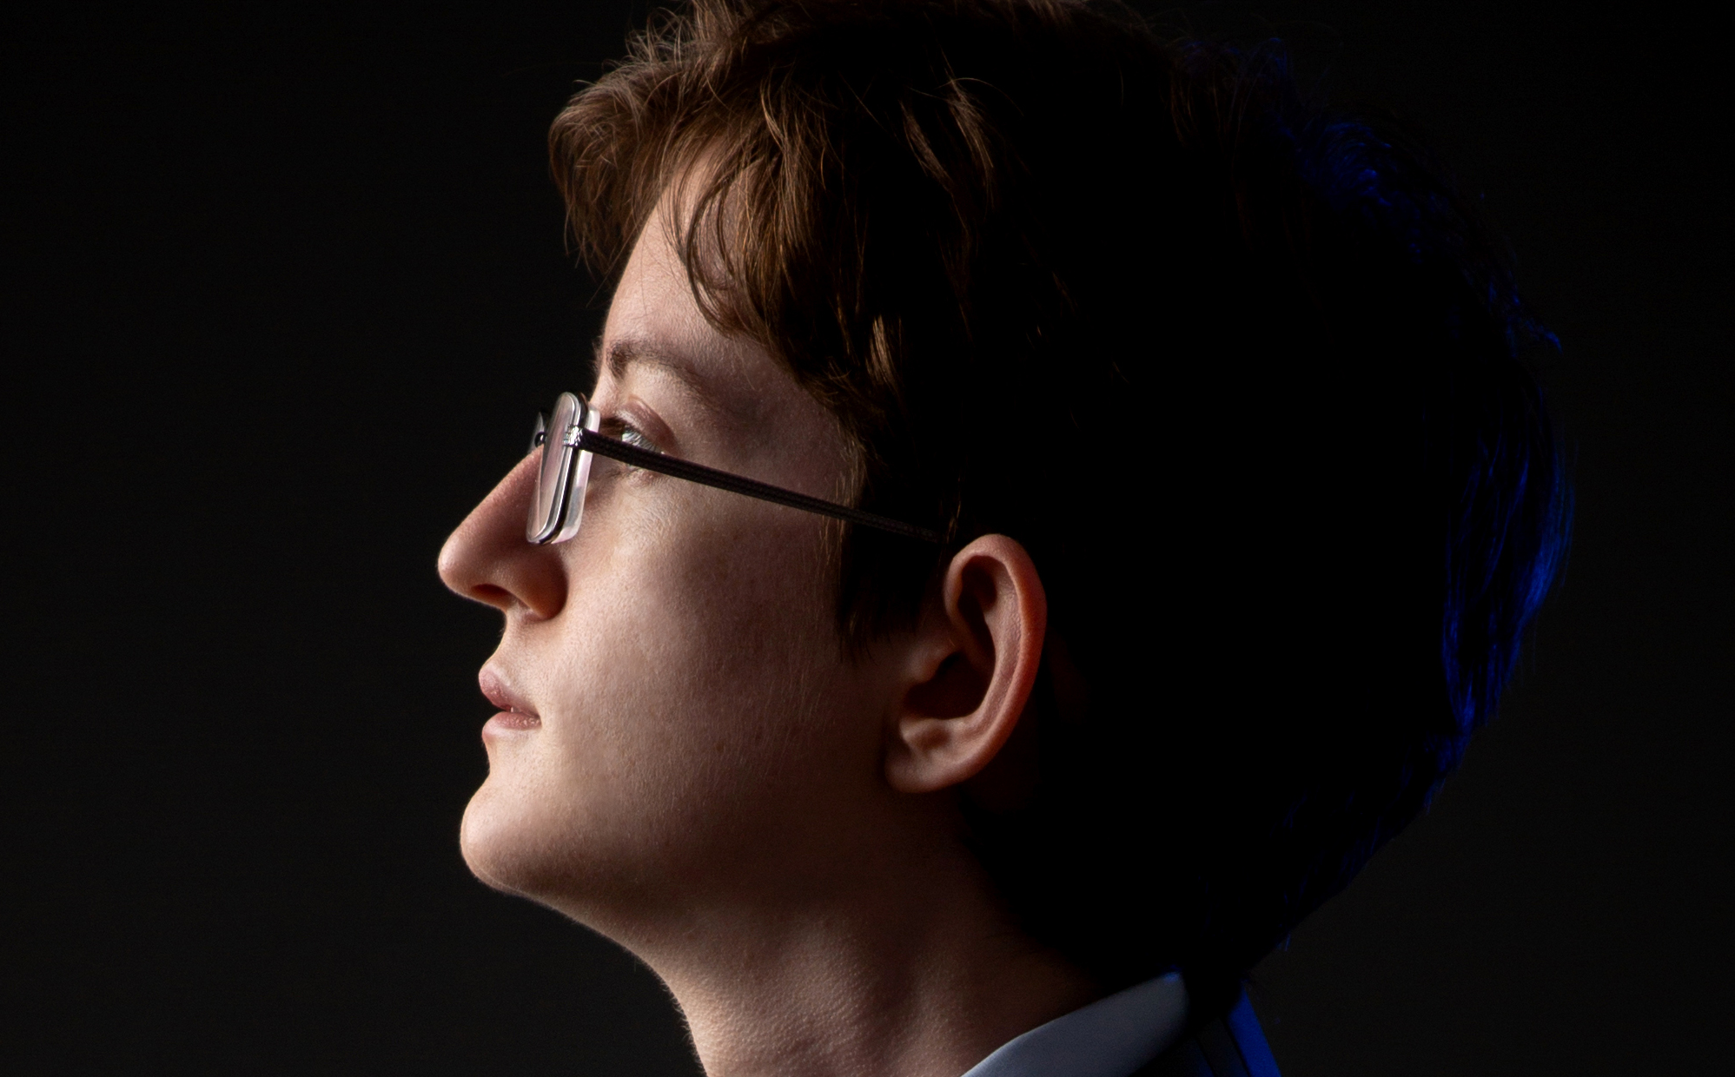
Some Other Mirror | 16 October / 7pm
Studio 1 / Theatre
“I saw a world where everyone was so in love with transition.”
It’s Laurie’s second go at puberty, aged 23. One performer plays multiple characters in dialogue, jumping back and forth through gender and time. This is a true story of how masculinity is born, dies, and gets reinvented. Full of songs, humor, and emotional highs, Some Other Mirror is a frenetic and methodical performance about becoming a man.
“Beautifully and gently crafted.” Tabby Lamb
"An absolutely genius mashup of stand up and theatre that had me laughing from start to finish.” Audience Feedback
BSL Interpreted
Creative Meet Up
Age guidance 16+
Standard / £10 | Live Pass / £7

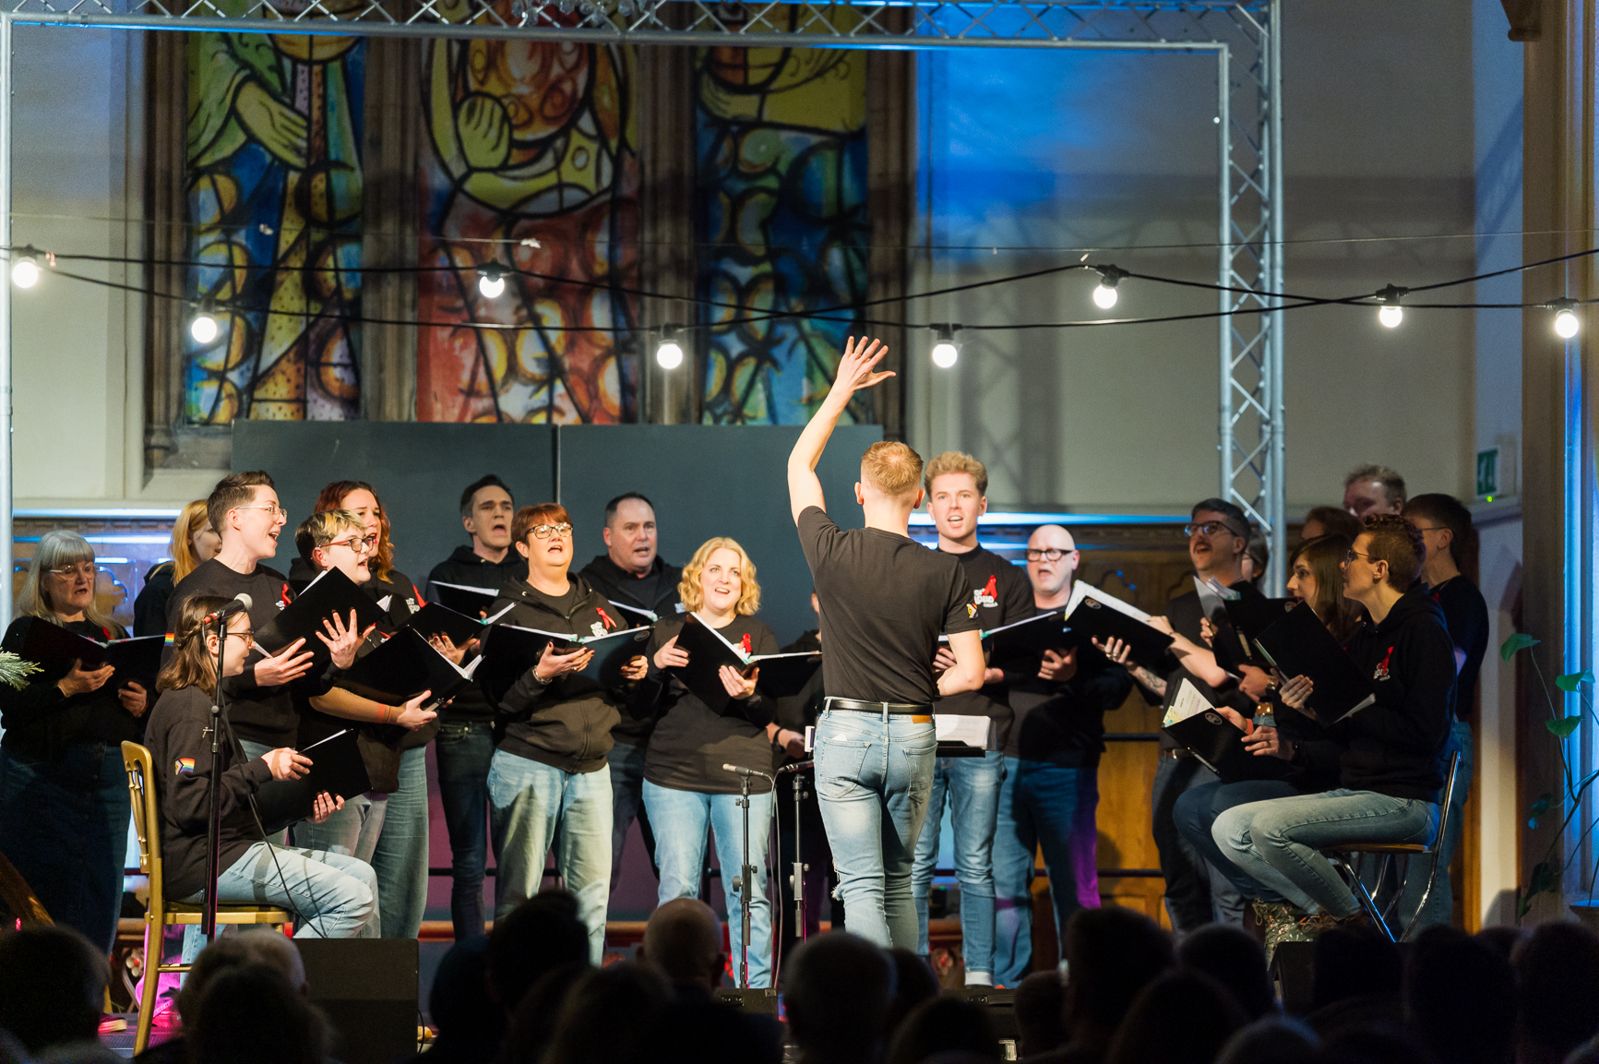
OUTLoud Lincoln presents
DIVAS! | 24 October / 7.30pm
Auditorium / Concert
DIVAS! is a spectacular celebration of the iconic artists who shaped pop music and inspired generations to sing out loud. Featuring OUTLoud Lincoln performing music from legendary artists including Adele, Lady Gaga, Tina Turner, Chaka Khan, Anastacia, Loreen and more, this high-energy concert is packed with powerhouse vocals, rich harmonies and unforgettable pop anthems. Expect emotional ballads, camp classics, dancefloor favourites and theatrical flair in a show bursting with personality and pride. Whether you love soaring diva vocals or iconic singalong moments, DIVAS! promises an uplifting evening of music, glamour, energy and unapologetic fabulousness.
BSL Interpreted
Standard / £15 | Live Pass / £12

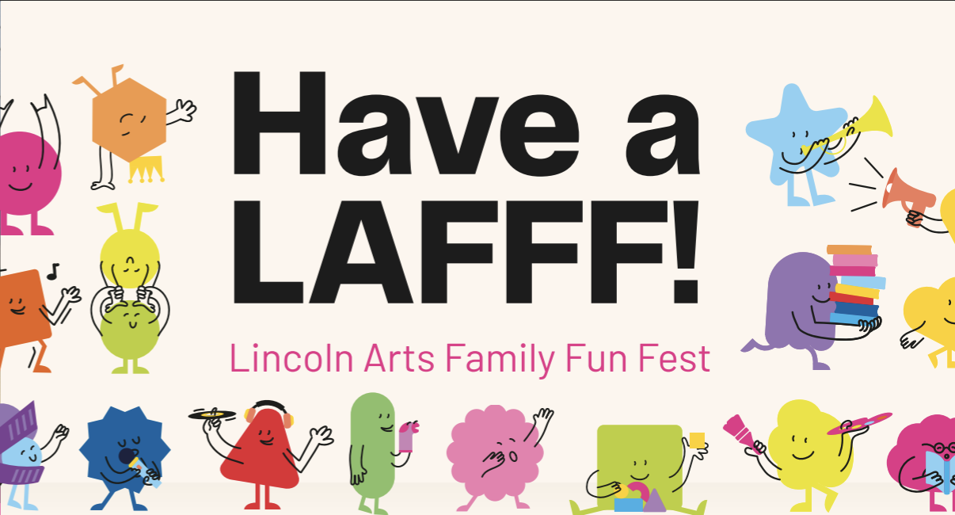
Lincoln Arts Centre presents
Have a LAFFF! | 31 October / All day
Lincoln Arts Centre / Family
Lincoln Arts Family fun Fest returns in October half term for a day of free activities for families in Lincoln/shire with children aged 0-11 years. Supported by Arts Council England and our Every Child scheme, Have a LAFFF is part of our wider commitment to welcoming and accessible arts, offering joyful memories and creative expression for every child in our community.
With two main events, this mini LAFFF brings you On Your Bike Baffo and So Unfair! As well as illustration and classical music workshops. It’s a fun filled day, with Halloween costumes encouraged!
Free Ticket

Graham Braidwood
Fatt Projects presents
Send in the Clowns: Unpopular! | 14 November | 7.30pm
Auditorium / Musical
Send In The Clowns is a filthy, outrageous, and joyful revue show celebrating the magic and madness of musical theatre.
This time the Clowns are taking on the megamusicals of the 80s, 90s, and 00s in their biggest show yet, ‘UNPOPULAR!’. We’re talking big blockbuster musical theatre SPECTACLE - think mechanical barricades, all-singing revolutions, flying helicopters, web-slinging spidermen, and belting witches flying on broomsticks; all in a tiny black box theatre… What could possibly go wrong?!
Age Guidance 18+
Band A / £22 | Band B / £20 | Live Pass / £15

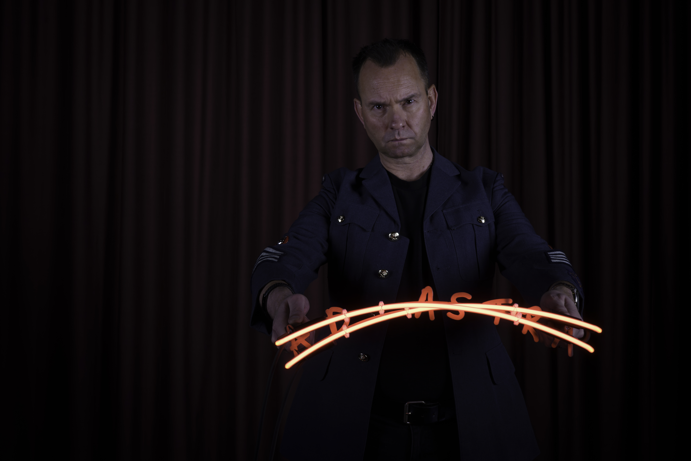Annabel McCourt
Annabel McCourt presents
Ad Astra | 12 November – 3 December
Gallery / Exhibition
This new work by artist McCourt builds on her earlier piece Per Ardua, which explored the experiences of LGBTQ+ personnel in the RAF affected by the historic ban on homosexuality. Taking its title from the RAF’s official motto, Per Ardua Ad Astra (“through adversity to the stars”).
For Ad Astra, McCourt invites members of the wider community to contribute their own stories through conversation and photography. Gathering voices shaped by injustice, stigma or erasure, the project will form a new constellation of shared experiences, an evolving artwork that creates space for dialogue, reflection and collective healing.
Free entry

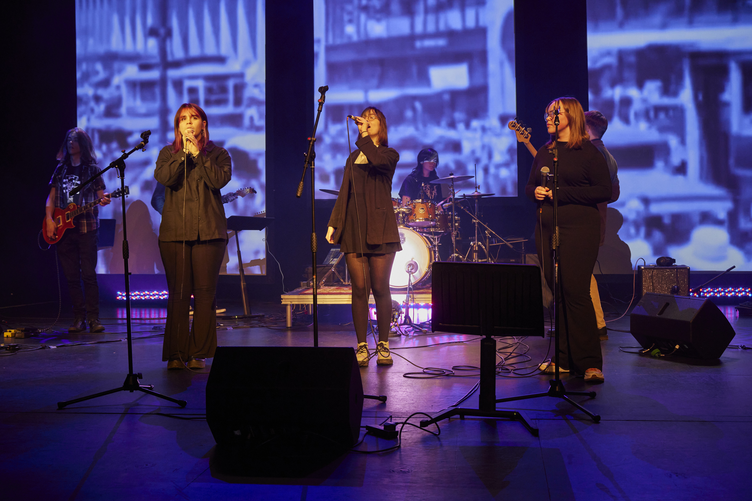Phil Crow
BA Music presents
Resistance and Reinvention | 30 November – 2 December
Auditorium / Music
Join student performers from the University of Lincoln’s Music degree for three nights of bold, genre-spanning work shaped by resistance and reinvention. Responding to the season’s Loud and Proud theme, students explore how music can challenge norms, amplify marginalised voices, and how styles can be reinvented.
- Monday 30 November, 6.00–8.00pm – a laid-back early evening concert of instrumental, choral and folk music
- Tuesday 1 December, 7.00–9.30pm – an evening of jazz, pop and acoustic acts
- Wednesday 2 December, 7.00–9.30pm – an eclectic mix of music presented by bands from across the course
Standard / £3 | Live Pass / Free

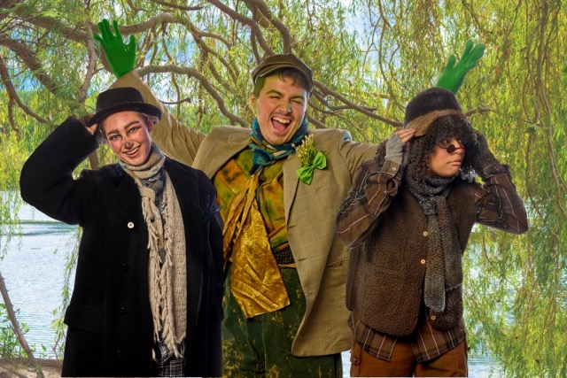Phil Crow
Lincoln Arts Centre and Lincoln School of Creative Arts presents
The Wind in the Willows | 10-20 December
Auditorium / Family
This December you’re invited to the very grandest of places for your Christmas celebrations — the one and only Toad Hall!
Following last year’s wildly enthusiastic audience reception to Alice in Wonderland, Lincoln Arts Centre and Lincoln School of Creative Arts are partnering once again to present their latest breathtaking co-production: a brand-new theatrical adaptation of Kenneth Grahame’s enduring tale of adventure, loyalty and the strength of even the most unlikely friendships.
The Wind in the Willows is brimming with laughter and excitement, live music, vibrant imagery and playful imagination, as Ratty, Mole and Badger try their very best to help the rascally Mr Toad out of all sorts of trouble…
BSL performance – Saturday 12 December 2pm
Relaxed Performance – Sunday 13 December 2pm
Band A / £26 | Band B / £22 | Band C / £18 | Band D / £15 | Live Pass / £12.50

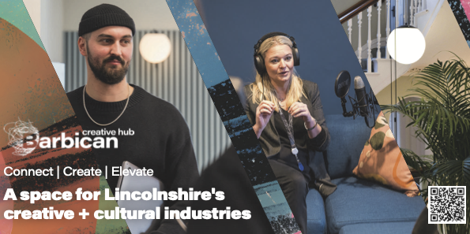
Barbican Creative Hub
Connect | Create | Elevate
A space for Lincolnshire’s creative + cultural industries
Join a growing community of creatives, freelancers and businesses
- Membership designed to help you connect, create and elevate. Enjoy unlimited coworking, exclusive events and development programmes, member discounts, and access to state-of-the-art technology in The Hive, plus our Podcast & Content studio. You'll also have opportunities to spotlight your work and raise your profile.
- Choose from flexible workspaces such as collaborative coworking in The Hub to your very own creative office studio.
- Access a vibrant programme of events, workshops, conferences and exhibitions designed to support, inspire and connect.
- Hire meeting rooms for small team sessions or host larger events in The Cube.
- In-house café, Salt & Fettle - launched June 2026 discover the Art of better eating.
Follow us @barbicancreativehub | barbicancreativehub.com
Contact us at info@barbicancreativehub.com
Access
We offer a wide range of facilities to ensure that you have a comfortable and enjoyable experience with us: The Box Office, Café Bar and Auditorium are all ground floor accessible. There is a lift to provide access to the first floor Balcony and Studios 1, 2, 3 and X and on each floor is an accessible toilet.
The Box Office desk is a short distance from the main entrance. Part of our Box Office desk is a lower level for easy access.

Seating and the Main Auditorium
The auditorium has spaces available for wheelchairs – companions can get a ticket free of charge. These designated spaces are located on the ground floor of the auditorium and gives guests plenty of space to sit comfortably. Should you wish to reserve a wheelchair space, you can now do this online – simply log into your account, go to ‘other preferences’ and amend your access requirements, once you have done this you will be able to book seats in a wheelchair accessible space. There’s a full guide on website called the Accessible Booking Guide if you would like to find out more – alternatively, please contact the Box Office on 01522 837600.
Our auditorium seating is tiered, except the seating on Row A. All other seating is only accessible via steps. Please contact our Box Office if you require accessible step-free seating.
The auditorium is equipped with an induction loop system. If you require access to this, please inform the Box Office staff.

Assistance Dogs are welcome in all areas of the building and we will happily look after your dog whilst you enjoy the performance.

Parking
The university carpark has parking spaces available to Blue Badge Holders.
How do I book an Essential Companion ticket?
You can now self-select your own access criteria via your account. Simply log in, go to ‘Other Preferences’ and select the tags you would like to add to your account. Once you have done this, you will be able to book accessible seating and essential companion/carer tickets online without calling the box office in advance.
You can read more on what these tags do and how to use them in our Accessible Booking Guide which you can download from our website.
Alternatively, you can still book accessible and essential companion/carer tickets by calling our box office on 01522 837600 and a member of our team will be happy to process your booking. If we’re not open or you’ve been unable to leave a message, then please email us via enquiries@lincolnartscentre.co.uk and we’ll be able to reserve the tickets for you and contact you later to process your order.
Familiarisation Visits
We are happy to show you around prior to your visit and give you a tour of our wonderful spaces at a quieter time in the venue to ensure you have all the information you need. Alternatively, you can experience a digital orientation of the building on our website.

How to book
Box Office Opening Hours: Monday – Friday 10-4 and one hour prior to events.
01522837600
Booking Online
You can book your tickets online through our website at https://lincolnartscentre.co.uk/whats-on/
If you can’t find the event that you’re looking for on the What’s On page, you can search for it using the filters or the search bar. Once you’ve found the event, click the Book Now button to purchase your tickets.
If you have an online account with us already, you’ll be able to log in. If not, you’ll need to set one up. Please be aware that the email address your account is linked to is the one that we will use to send your order confirmation and e-tickets.
Booking in Person
You can book your tickets directly from our Box Office. Pop into the venue during our opening hours and a member of our Front of House team will be more than happy to process your order.
The University of Lincoln is a cash free organisation. Payments can be made by debit or credit card only.

Booking Over the Phone
To book your tickets over the phone, simply call us on 01522 837600 during our regular opening hours. Our Box Office opens an hour before the start of an event, tickets are available to purchase over the phone during this time.
You can also use this number to contact us if you have any questions or queries regarding events, tickets, venue access, etc.
If you are having difficulty getting through on the phone, we might just be busy! If so, please either leave us a voicemail clearly stating your name and contact telephone number, fill in our contact form, or try calling again in a couple of minutes.
Babes in Arms Policy
All babes in arms under 18 months go free, however you will still need to book them a ticket. You can call us to do this.
University of Lincoln Staff
Staff can get access to staff discount on selected shows. Discount varies per event.

How to find us
Based in the heart of University of Lincoln’s striking city centre campus, Lincoln Arts Centre is well connected with excellent public transport links both locally and nationally.
Location
Lincoln Arts Centre, Brayford Pool, University of, Lincoln LN6 7TS (located next to the Engine Shed)
Getting Here
The city of Lincoln is 40 miles east of Nottingham on the A46 and 40 miles south of the Humber Bridge on the A15. Follow the signs for University of Lincoln and Brayford Pool. SAT NAV/Google Maps/Apple Maps users, please use our LN6 7DQ postcode.
Getting here by public transport
Lincoln Arts Centre is a short 10 minutes’ walk from Lincoln Central Station and Lincoln City Bus Station.
A number of services run close to the venue. For details of services call Stagecoach on 0845 605 0605 or Traveline on 0871 200 2233

