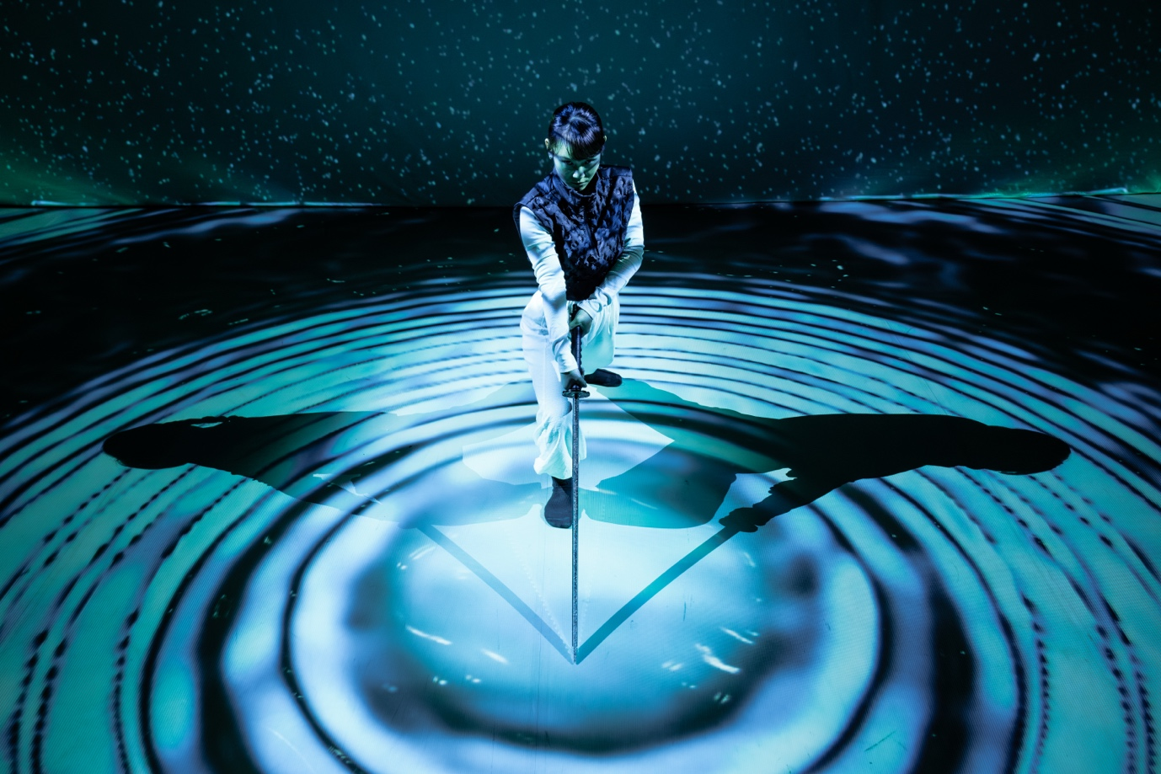

In Their Words

Spring 2026

Lincoln Arts Centre

This Spring, we present In Their Words, a season celebrating the voices, experiences, and creativity of women shaping our world. With original commissions, artworks and visual performances, the programme highlights resilience, imagination, and connection in women’s stories.

We open with Community Film Celebration (16 Jan), in partnership with University of Lincoln’s Film Production programmes and Lincoln City Council, showcasing community groups in Lincoln. Alongside, Women on Film premieres, celebrating women from all backgrounds making an impact locally, viewable across our digital channels and building.

Other season highlights include LAS Theatre’s The Littlest Yak (7-8 Mar), nominated for four OffWestEnd Awards; Stuff and Nonsense Theatre Company’s The Adventures of the Little Red Hen (10-11 Apr); and Yukiko Masui’s RONiN (25 Apr), where dance, swordplay, and digital projections tell the story of a lone female swordfighter.

In visual arts, we’re working with Extraordinary Us on Museum of Me (Mar), transforming our public spaces to celebrate the women who make Lincoln thrive, and with Mansfield Museum on Womansfield (3-23 Apr), showcasing ‘Creative Women Together’.

Local voices feature strongly: The Whore Queen (13 Feb) by Ellie Grace retells Anne Boleyn’s story, and Sugar Theatre’s F*ck You Claire (13 Mar) explores the mid-twenties experience. Both emerged from Demo, our platform for new work, returning this spring (5 Feb).

Lincoln School of Creative Arts contributes with Titus Andronicus (20 Jan), Macbeth (22 Jan0, Dance Showcase (30 Jan), Music Showcase (23-25 Mar) and Launch Fest (Apr), while youth dance platform True Motion returns (14 Mar) with its biggest programme yet.

Finally, Indie Lincs (5-7 Feb) champions bold, original low and micro-budget films, no remakes, no sequels, celebrating creative, connection and cinematic storytelling in Lincoln.

As the Spring season draws to a close, we look ahead to the activities we’ve got lined up in the summer. Musical Theatre students will provide a plethora of musical delights again this year as part of their Summer of Musicals line-up, focusing on mistaken identity and gender play. We’ll have the second iteration of Have A LAFFF! (Lincoln Arts Family Fun Fest) in July to kick off the summer holidays with your little ones, including an enhanced programme of free or affordable activities for families, only made possible by donations to Every Child.

Ben Anderson
Creative and Executive Director, Lincoln Arts Centre

Join the Conversation
01522 837600
www.lincolnartscentre.co.uk

@lincsartscentre
#InTheirWords

Café Bar
Our Café Bar is open 8.30am - 6.00pm* every weekday and one hour prior to events.
*Opening times may vary due to changes in seasonal demand and academic timetable.

Please note: The University of Lincoln is a cash free organisation. Payments can be made by debit or credit card only at our Café Bar.

Every Child

Every child is creative, but not every child can access Lincoln Arts Centre, and we want to change that.

Every Child is Lincoln Arts Centre’s donation scheme to make certain every child can get creative with a visit to our purpose-built facility. Whether that be watching a show, learning a new skill or expressing themselves through their own performance or visual art.

It’s easy to donate. Just head to our website by scanning the QR code or add an optional donation when you buy a ticket.

Help us make sure that every child is welcomed into the Lincoln Arts Centre

Live Pass

If you’re aged 16-30 or a student of any age, don’t forget to sign up to Live Pass – offering a range of discounts on shows and in our cafe, plus exclusive events and a network of like-minded creatives.

Don’t miss out, sign up online or at our box office.

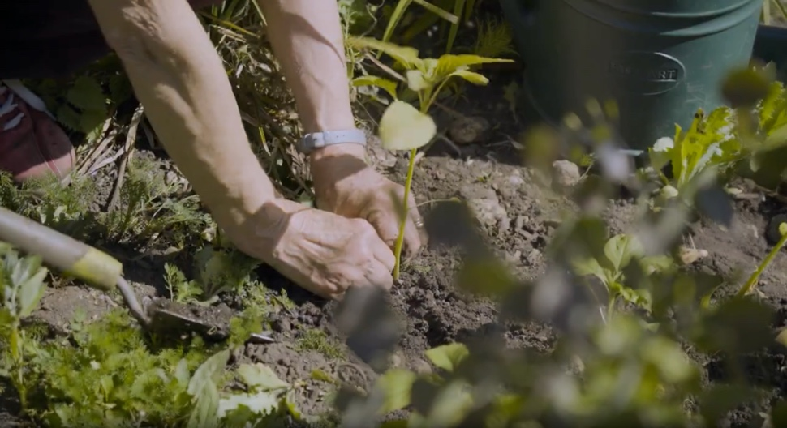
Community Film Celebration January 16 / 4pm
Auditorium / Film

Highlighting the power of community within Lincoln.

Join us for an annual showcase of documentary films that celebrate the vibrant community groups and organisations supported by City of Lincoln Council. This civic documentary partnership shines a spotlight on the incredible work happening across the city, thanks to the dedication of voluntary sector organisations, charities, and community groups.

Thanks to the Government’s UK Shared Prosperity Fund and Investors in Lincoln, the City of Lincoln Council has funded community organisations through multiple initiatives including a city-wide grants programme.

Women On Film
Meet the women driving change where we live. Women on Film is a series of short portraits celebrating their vision, courage, and community spirit – streaming online and lighting up our venue this spring.

All the films are made by talented University of Lincoln BA (Hons) and MA Film Production students. The event also marks the launch of an online repository of the films produced in partnership with Lincoln Arts Centre, City of Lincoln Council and the University of Lincoln School of Creative Arts.

Free tickets / Booking required
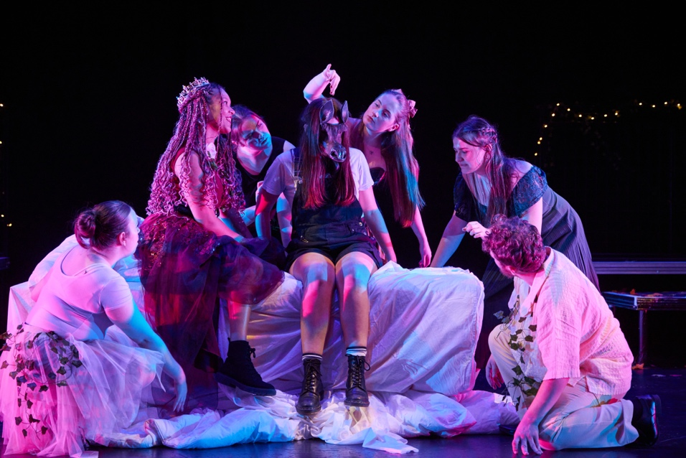
Lincoln School of Creative Arts Presents
Titus Andronicus January 20 / 7.30pm
Auditorium / Theatre

Rome is approaching the end of its time, and the barbarians are at the gates... or are they already inside? Shakespeare's play of the end of empire is also his bloodiest. Murder, revenge and spoliation shape this classical tragedy of what was one of Shakespeare's most popular plays... and the first he ever wrote.

Standard / £7
Live Pass / £5

Macbeth January 22 / 7.30pm
Auditorium / Theatre

"By the pricking of my thumbs, Something wicked this way comes."

For centuries, superstition has plagued performances of Shakespeare's notorious tale of "vaulting ambition", ruthless power-lust, and the lure of supernatural suggestion. Join Level Two BA Drama students as they bring a performance of the cursed play to the LAC stage.

Standard / £7
Live Pass / £5

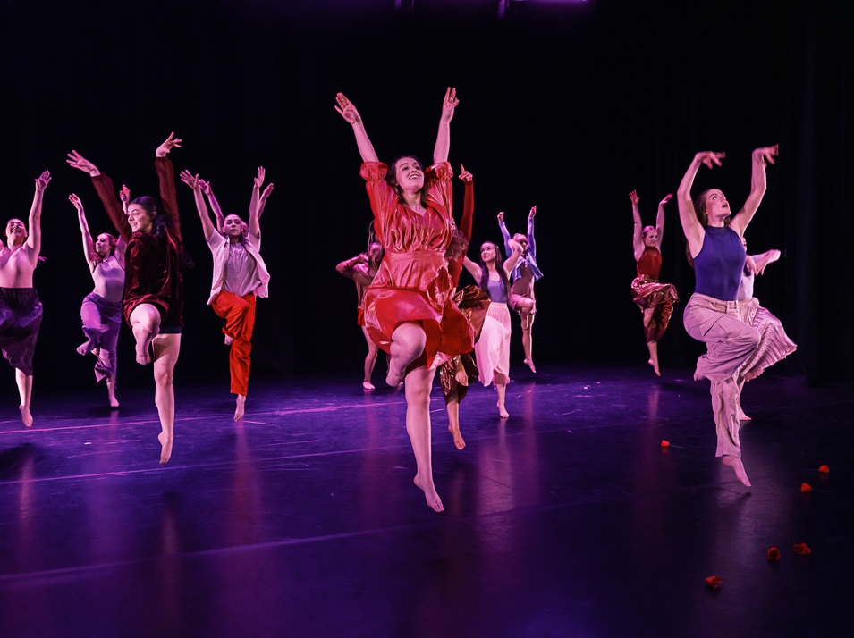

Lincoln School of Creative Arts Presents
BA Dance Showcase January 30 / 7pm
Auditorium / Dance

Come and join us for an evening of dance celebrating the fantastic work from the BA Dance Programme that has been developed and produced over the academic year. Featuring work choreographed by students, faculty, and guest choreographers, this showcase will be filled with creativity, energy, and inspiration. Whether you’re a dance enthusiast or new to the art form, this evening promises to captivate and engage audiences of all ages.

Standard / £7
Live Pass / £5

BA Music Spring Showcase March 23-25 / 6pm
Auditorium / Music

Join student performers from the University of Lincoln’s Music degree programme for three evenings of music from across genres and eras.

Monday 23 March, 6pm – instrumental and choral music celebrating spring
Tuesday 24 March, 6pm – a mix of music including small groups and soloists
Wednesday 25 March, 6pm – an eclectic mix of pop music
Standard / £3

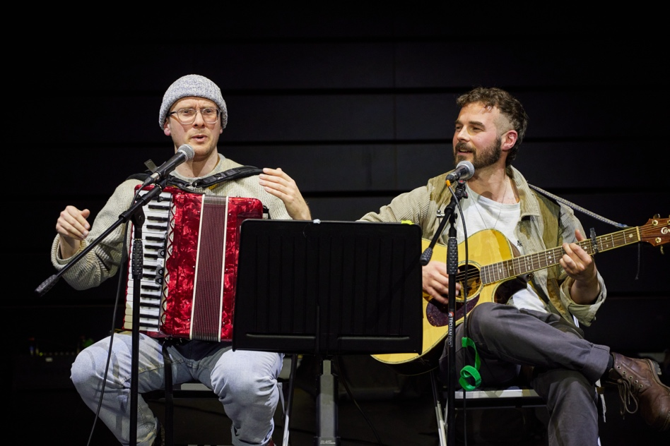
Indie-Lincs Presents
Indie-Lincs 2026 February 5 – 7
Lincoln Arts centre / Film

Indie-Lincs is an international film festival that champions micro budget feature length and short films, and you the filmmakers. We pride ourselves, and have had superb feedback, on our welcoming atmosphere at the festival.
Our aim is to help the best independent filmmakers from around the world showcase their original work and network successfully with their audience, other filmmakers and the independent film-making community..

Day Pass / £15
Day Pass + Thursday Evening Access / £20
Full Festival Pass / £30
Live Pass tickets available, check online for details

Demo February 5
Studio / Mixed Arts

Be part of developing the next big thing!
Demo is your chance to see the best new artistic ideas tested out in front of an audience, often for the very first time.
Offering a selection of new work from the most exciting artists both regionally & nationally, this event encourages critical discourse in a relaxed and supportive environment.

£7 Full
£5 Live Pass

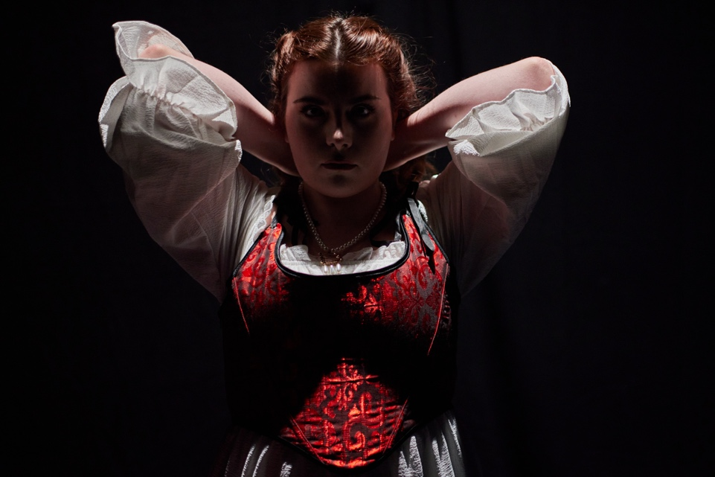
The Whore Queen February 13
Studio 2 / Theatre

You wanna get to know the “Real Anne Boleyn” right? Now’s your chance!
But she may not be what you are expecting...
Anne is dragged through her memories by what history has deemed interesting. She’s fighting for her whole story to be heard before time reduces her down to a single word in a limerick - ‘beheaded’.
She’s been forced to relive these same events for nearly 500 years - and she is pissed!
This eclectic one person play written and performed by Ellie Grace explores the boundaries of objectivity and historiography through the life of one of history’s most iconic Queens.

***** “Emotional, Powerful, Feminine”
**** “Tragically Good”

Standard / £10
Live Pass / £7
Age Guidance: 14+

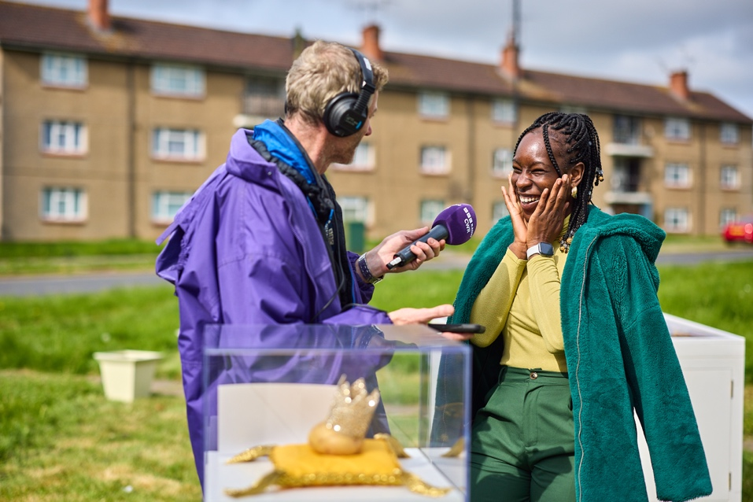

Coming Soon…
Extraordinary Us Presents
Museum of Me

This March is all about you! Ever questioned if you are worthy of adoration? You are Lincoln. Stay tuned to find out more about an extraordinary project about the everyday lives quietly shaping the heartbeat of our city.
One by one, people are opening the doors to their world, sharing the objects, memories and moments that make them who they are. Together, these stories form a living snapshot of Lincoln, told through the things we keep close.

Stay Tuned!

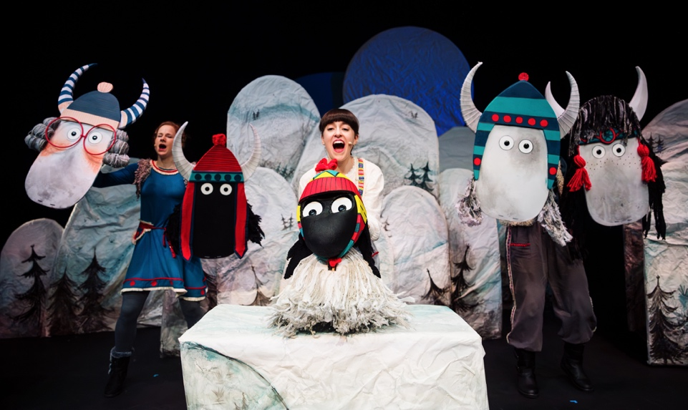

LAStheatre Presents

The Littlest Yak March 7 & 8 / Various times
Auditorium / Family

Gertie is great at being THE LITTLEST YAK, with the CURLIEST, WHIRLIEST wool and the GRIPPIEST of hooves for clip-clopping up cliffs. Only, Gertie doesn’t want to be LITTLE, she wants to grow UP!
A gorgeous story celebrating YOU being perfect…just the way you are!
This musical adaptation of the award-winning children’s book will delight audiences young and old with beautiful puppets, catchy tunes and an uplifting tale of self-acceptance.
LAStheatre brings The Littlest Yak to the stage in spectacular fashion. Join them for a dazzling adventure, into the heart of the Himalayas.
Nominated for a YAKTASTIC four OffWestEnd Awards!

Adult / £10
Child / £12
Family (2 adults, 2 children) / £40

Touch tours available
BSL interpreted performance March 8 / 10.30am
Relaxed performance March 8 / 1.30pm

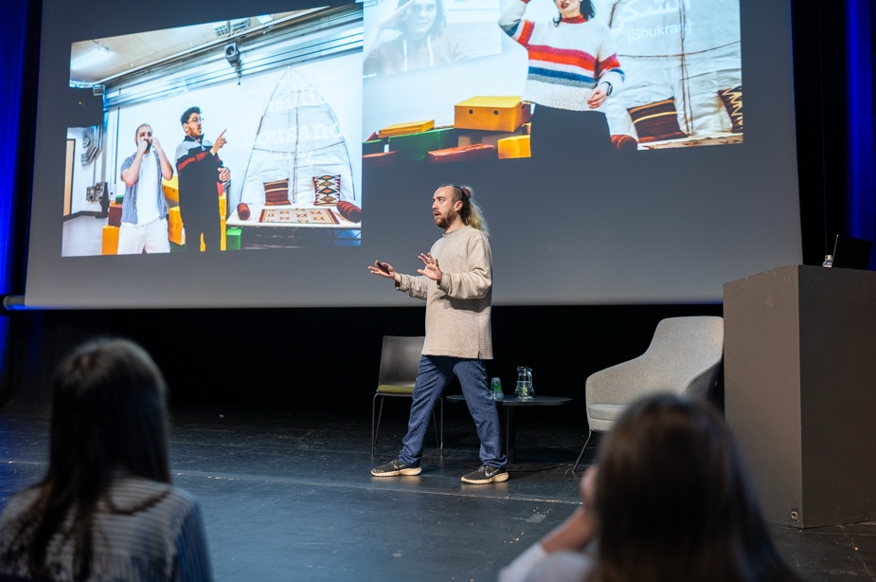

Lincoln Arts Centre Presents

Technically Speaking March 12 / 10am
Auditorium / Conference

Join leading creative industries professionals and event specialists to explore how rapid technological change is reshaping the current industry and has done so in the past.
Expect thought-provoking talks, hands-on insights into the latest equipment, and time to connect with local venue technicians, industry employers, and peers.
From speculating about the future of events to hearing reflections on the industry’s history, you’ll get a sense of where the event production industry is heading and get a chance to meet those who will take us there.
Whether you’re an experienced professional, a freelancer, or just starting out, this is your chance to see what’s next – and how you can be part of it.

Free tickets / Booking required


Sugar Theatre Presents
F*CK You Claire March 13 / 7pm

‘F*ck You, Claire’ is a playful exploration of mid-twenties confusion, existential curiosities and fears, and mental health recovery. Dealing with some heavy topics but in a fluffy, lighthearted way, working WITH the audience to create a night at the theatre that we hope will stick with you.
Plus, it’s got a banging soundtrack…

Standard / £10
Live Pass / £7
Age Guidance: 14+

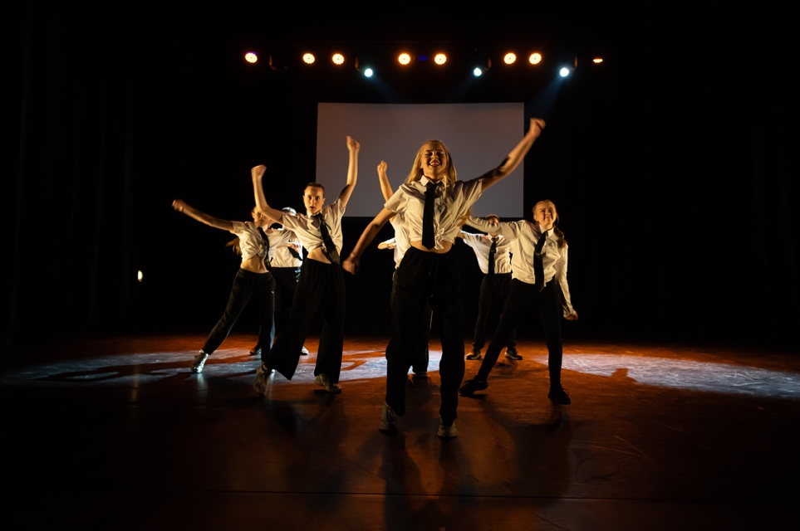

True Motion March 14 / 7.30pm
Auditorium / Dance

Join us for an inspiring event that champions the next generation of dance artists. True Motion celebrates youth dance talent from across Greater Lincolnshire. This isn't just a showcase; it's an opportunity to witness dedicated young dancers, from grassroots dance groups to university performers, bringing their passion to a professional stage. Prepare to be moved by a diverse range of dance styles and feel the energy of each performance.

True Motion is a collaborative initiative by the Hub dance team, Lincoln Arts Centre, the University of Lincoln, and Fabric. Don't miss this chance to support local talent!

Adult / £13
Child / £10

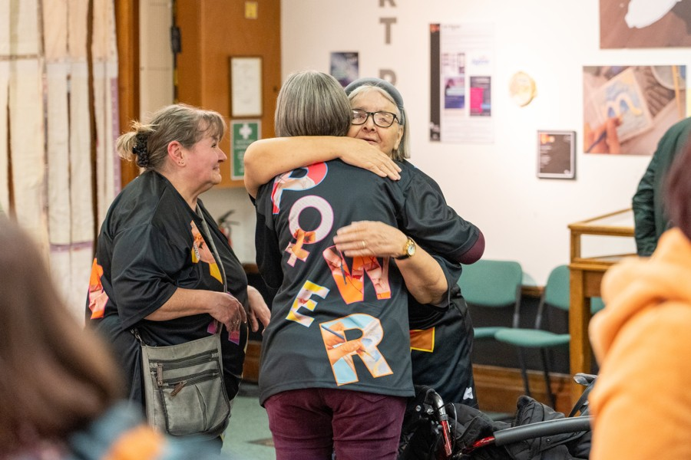

Womansfield: Sisterhood and Healing in the Museum April 1 – 26
Gallery / Visual Arts

Womansfield: Sisterhood and Healing in the Museum is the latest exhibition from the Mansfield Museum’s Green Power initiative. Running in April 2026, the exhibition showcases powerful artworks created by women participants and local freelance artists. Through painting, sculpture, and mixed media, the works raise awareness of the warning signs of unhealthy relationships and advocate for an end to gender-based abuse. Womansfield is more than an exhibition – it is a call for change, shaped by a community of women using art as a tool for resilience, solidarity, and hope.

Free entry

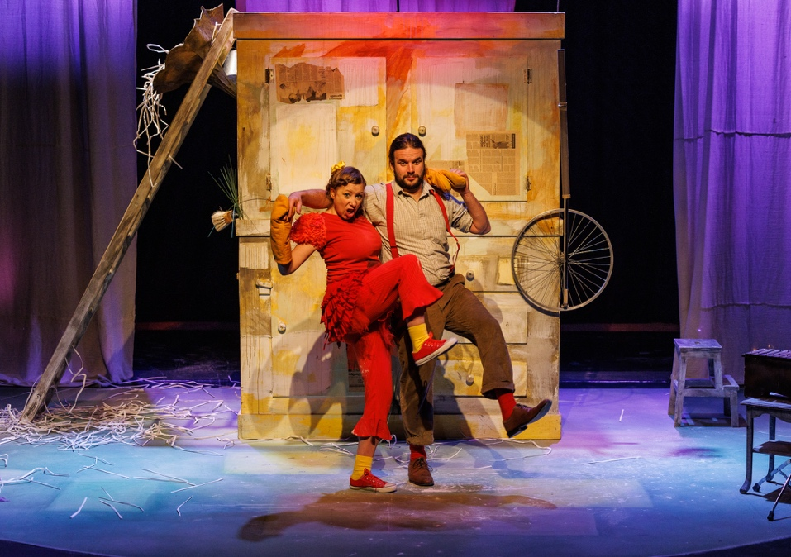

Stuff and Nonsense Theatre Company Presents
The Adventures of the Little Red Hen April 10-11
Auditorium / Family

Making bread is hard work, but it would be a lot easier if the lazy farmyard animals got off their reclining sofas and lent a hand! Join our plucky little hen as she finds her own way to get stuff done. An energetic adaptation of this much-loved story, featuring a breath-taking combination of brilliant puppetry, live music and unforgettable comedy.

Suitable for all the family (recommended for ages 3-10).

Adult / £12
Child / £15
Live Pass / £10
Family (2 adults 2 children) / £45

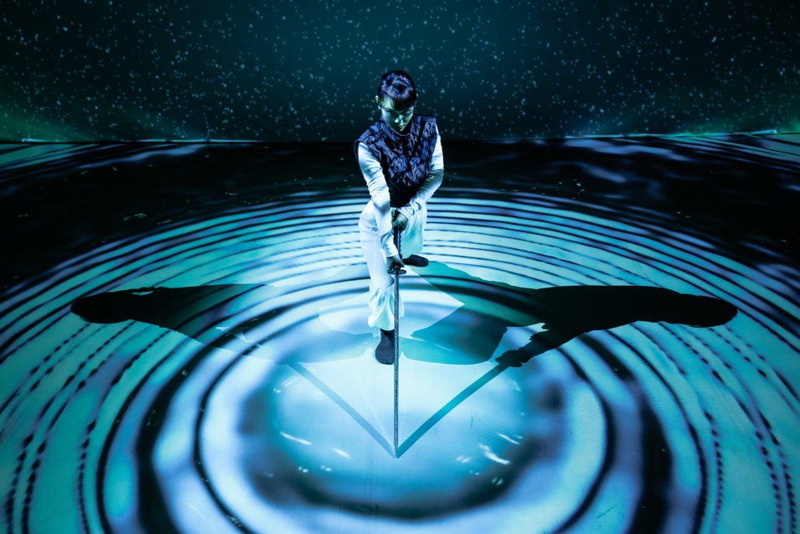

The Place and Yukiko Masui Presents
RONiN April 25 / 7pm
Auditorium / Dance

Dance, swordplay, and cutting-edge digital projections come together to tell the story of a lone female swordfighter navigating honour, resilience and survival in a male dominated world.
Inspired by the legacy of Japan's ronin—masterless samurai who lived by their own code—this performance follows the journey of a fearless woman swordfighter who faces off against powerful adversaries, challenging both herself and those who stand in her path.
Through a captivating blend of movement and technology, RONiN takes audiences through Japan’s four seasons, from spring's cherry blossoms to winter's silent snowfall, creating an anime-inspired realm that merges ancient traditions with modern visual storytelling.
RONiN is a new collaboration between award-winning choreographer Yukiko Masui and digital artist Barret Hodgson, produced by The Place.

Age guidance: 10+
Standard / £15
Live Pass / £5

Coming this May
Lincoln School of Creative Arts Presents
Summer of Musicals

Following the phenomenal success of our 2025 Summer Season - which saw five thrilling musicals, including four British works and three premieres, captivate over 1,000 audience members - our musical theatre programme returns in 2026 with an even more ambitious line-up. This year, we celebrate womxn’s stories and voices through a bold suite of shows that weave together magic, mystery, and resilience.
Audiences can expect stirring tales of transformation and self-discovery, from enchanted lands to windswept shores, and heroines who challenge the odds with courage, wit, and song. Our 2026 season breathes musical life into classic stories of mistaken identity and gender play, as well as new narratives that spotlight the power, complexity, and joy of womxn’s experiences. Join us for a summer of spellbinding theatre that dares to reimagine the past, revels in the present, and sings of radical futures.

Access
We offer a wide range of facilities to ensure that you have a comfortable and enjoyable experience with us: The Box Office, Café Bar and Auditorium are all ground floor accessible. There is a lift to provide access to the first floor Balcony and Studios 1, 2, 3 and X and on each floor is an accessible toilet.

The Box Office desk is a short distance from the main entrance. Part of our Box Office desk is a lower level for easy access.

Seating and the Main Auditorium

The auditorium has spaces available for wheelchairs – companions can get a ticket free of charge. These designated spaces are located on the ground floor of the auditorium and gives guests plenty of space to sit comfortably. Should you wish to reserve a wheelchair space, you can now do this online – simply log into your account, go to ‘other preferences’ and amend your access requirements, once you have done this you will be able to book seats in a wheelchair accessible space. There’s a full guide on website called the Accessible Booking Guide if you would like to find out more – alternatively, please contact the Box Office on 01522 837600.

Our auditorium seating is tiered, except the seating on Row A. All other seating is only accessible via steps. Please contact our Box Office if you require accessible step-free seating.
The auditorium is equipped with an induction loop system. If you require access to this, please inform the Box Office staff.

Assistance Dogs are welcome in all areas of the building and we will happily look after your dog whilst you enjoy the performance.
Parking

The university carpark has parking spaces available to Blue Badge Holders.

How do I book an Essential Companion ticket?
You can now self-select your own access criteria via your account. Simply log in, go to ‘Other Preferences’ and select the tags you would like to add to your account. Once you have done this, you will be able to book accessible seating and essential companion/carer tickets online without calling the box office in advance.
You can read more on what these tags do and how to use them in our Accessible Booking Guide which you can download from our website.
Alternatively, you can still book accessible and essential companion/carer tickets by calling our box office on 01522 837600 and a member of our team will be happy to process your booking. If we’re not open or you’ve been unable to leave a message, then please email us via enquiries@lincolnartscentre.co.uk and we’ll be able to reserve the tickets for you and contact you later to process your order.

Familiarisation Visits
We are happy to show you around prior to your visit and give you a tour of our wonderful spaces at a quieter time in the venue to ensure you have all the information you need. Alternatively, you can experience a digital orientation of the building on our website.

How to book
Box Office Opening Hours: Monday – Friday 10-4 and one hour prior to events.
01522837600
Booking Online
You can book your tickets online through our website at https://lincolnartscentre.co.uk/whats-on/
If you can’t find the event that you’re looking for on the What’s On page, you can search for it using the filters or the search bar. Once you’ve found the event, click the Book Now button to purchase your tickets.

If you have an online account with us already, you’ll be able to log in. If not, you’ll need to set one up. Please be aware that the email address your account is linked to is the one that we will use to send your order confirmation and e-tickets.

Booking in Person
You can book your tickets directly from our Box Office. Pop into the venue during our opening hours and a member of our Front of House team will be more than happy to process your order.

The University of Lincoln is a cash free organisation. Payments can be made by debit or credit card only.

Booking Over the Phone
To book your tickets over the phone, simply call us on 01522 837600 during our regular opening hours. Our Box Office opens an hour before the start of an event, tickets are available to purchase over the phone during this time.
You can also use this number to contact us if you have any questions or queries regarding events, tickets, venue access, etc.

If you are having difficulty getting through on the phone, we might just be busy! If so, please either leave us a voicemail clearly stating your name and contact telephone number, fill in our contact form, or try calling again in a couple of minutes.

Babes in Arms Policy
All babes in arms under 18 months go free, however you will still need to book them a ticket. You can call us to do this.

University of Lincoln Staff
Staff can get access to staff discount on selected shows. Discount varies per event.

How to find us
Based in the heart of University of Lincoln’s striking city centre campus, Lincoln Arts Centre is well connected with excellent public transport links both locally and nationally.

Location

Lincoln Arts Centre, Brayford Pool, University of, Lincoln LN6 7TS (located next to the Engine Shed)
Getting Here

The city of Lincoln is 40 miles east of Nottingham on the A46 and 40 miles south of the Humber Bridge on the A15. Follow the signs for University of Lincoln and Brayford Pool. SAT NAV/Google Maps/Apple Maps users, please use our LN6 7DQ postcode.

Getting here by public transport

Lincoln Arts Centre is a short 10 minutes’ walk from Lincoln Central Station and Lincoln City Bus Station.

A number of services run close to the venue. For details of services call Stagecoach on 0845 605 0605 or Traveline on 0871 200 2233

