**ACCESSIBLE BOOKING GUIDE**

We have updated our online booking pathways so that anyone who requires access to specific seating areas or who requires access to an essential companion/ carer ticket can book their seats online without needing to contact the box office first.

**How does it all work?**

When you log into your account on our website you can now update your preferences. (see image below)

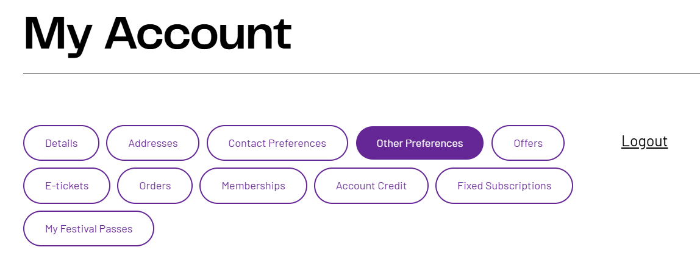

When you click into the ’Other Preferences’ page you will see that you can now update your access needs under the tab ‘My Accessibility’.

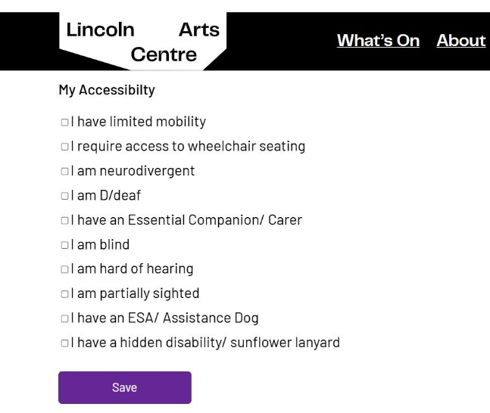

We have the following options to select from:

* I have limited mobility
* I require access to wheelchair seating
* I am neurodivergent
* I am D/deaf
* I have an Essential Companion/ Carer
* I am blind
* I am hard of hearing
* I am partially sighted
* I have an ESA/ Assistance Dog
* I have a hidden disability/ sunflower lanyard

You can select as many options that apply to you and they can change your access to certain seating areas or ticket offers.

If you have selected

* I require access to wheelchair seating

This option will allow you to book seats in our wheelchair seating area.

If you have selected

* I have an Essential Companion/ Carer

This option will allow you to book up to 2 complimentary tickets when you purchase an accessible ticket.

If you have selected any of the following

* I have limited mobility
* I am neurodivergent
* I am blind
* I am hard of hearing
* I am partially sighted
* I have an ESA/ Assistance Dog
* I have a hidden disability/ sunflower lanyard
* I am D/deaf

These options will give you access to other specific seating areas in the auditorium or sensory bags that can make your trip to the theatre more enjoyable. I.e. seating closer to a door or exit, seating closer to the stage, or seating that would be reserved for those requiring a BSL interpreter etc.

**How do I book wheelchair seating for a performance?**

Once you have selected, *I require access to wheelchair seating* on your preferences, your account will be updated, and you will be able to book the wheelchair accessible seating for our main house performances. These seats will have a wheelchair access icon instead of the standard blue dot to indicate that these are wheelchair accessible seats. (see the image below of our standard layout)

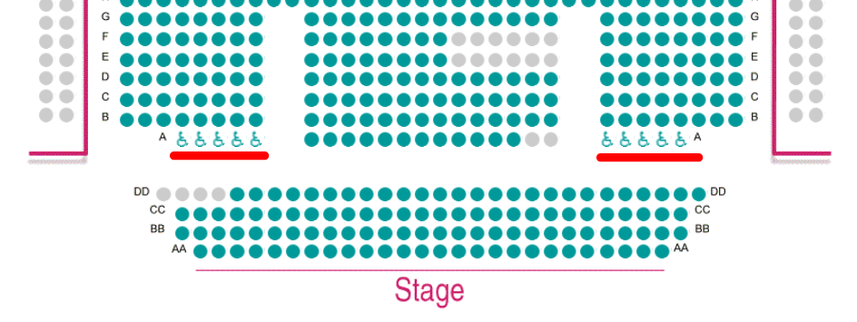

Please note: The layout of our seating plans are subject to change depending on the event type and as such, the wheelchair seating may not always be available in the same area. You can download our seating plans from our website or by clicking the link below.

[Seating Plans](https://static.lincolnartscentre.co.uk/app/uploads/2025/05/Seating-Plans.xlsx)

You’ll be able to add these seats to the basket and book your wheelchair accessible seating without needing to contact the box office.

If the seating is unallocated, you will still be able to book an accessible ticket, but there will also be a section where you can tell us what you need in the ‘Access Requirements’ box. This is not mandatory to fill out but just let’s our team know that you will be seated in your wheelchair for the duration of the performance.

**How do I access my complimentary tickets for my essential companion/ carer?**

Once you have selected the *I have an Essential Companion/ Carer* option on your preferences your account will be updated and will be able to access an offer for up to 2 complimentary essential companion/ carer tickets whenever you book an accessible ticket.

You may have already seen these ticket options available in the booking pathway (see image below)

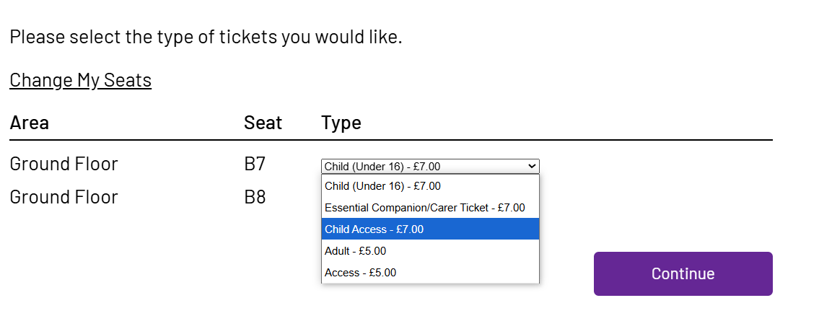

To access this ticket offer, simply add the accessible ticket you require to the basket and then add up to 2 Essential Companion/ Carer Tickets to the basket. If you are logged into your account, click continue and the companion tickets will automatically revert to zero. Then you can go ahead and complete your purchase.